Hotel Management System
Final Report


BS (SE) FALL 2019
Course Title: Database System
Course Code: CSS 2062
Name: Enrollment No:
Javairya Hussain 2019/Comp/AFN/BS(SE)/1928

Department of Computer Science and Information Technology
Jinnah University for Women
5-C Nazimabad, Karachi 7460
ACKNOWLEDGEMENT

I am extremely grateful to my supervisor, Ms Surraiya Obaid, for his capable direction, smart supervision and motivation that helped me to complete this assignment. Without his constant help, this assignment would not have been conceivable. I would like to thank the people of Department of Computer Science and Software Engineering for helping us with information and guidance that help us to finish the assignment. I owe a profound feeling of appreciation for all the people of Jinnah University for Women for giving us their direct and indirect help.

Table of Contents

Hotel Management System 4
Project Overview: 4
Objective: 4
Scope: 4
Entity relationship diagram: 4
Coding: 6
Button Coding in Events: 6
Access Tables: 8
Reports of tables: 9
Schema Diagram: 11
Entity Relation Diagram: 11
Screenshorts: 12
Conclusion: 13

Hotel Management System

Project Overview:
A hotel management system is a set of hotel software solutions that keep operations flowing. There are accounting packages, customer relationship management (CRM) packages, and a dizzying array of industry-specific software.
The entire project has been developed keeping in view of the Distributed client server computing technology in mind. The specification has been normalized up to 3NF to eliminate all the anomalies that may arise due to the database transactions that are executed by the actual administration and users. The user interfaces are browser specific to give distributed accessibility for the overall system. The internal database has been selected as Oracle 11g.The basic constructs of the tablespaces, clusters and radixes have been exploited to provide higher consistency and reliability for the data storage. The oracle 11g was a choice as it provides the constructs of high-level reliability and security. The total front end was dominated using HTML standards applied with the dynamism of JAVA server pages. The communication client was designed using servlets. At all proper levels high care was taken to check that the system manages the date consistency with proper business validations. The database connectivity was planned using the Java Data Base Connectivity, the authorization and authorization was cross checked at all stages. The user level accessibility has been restricted into two zones the administrative and the normal user zone

Objective:

The objective of Hotel Management system is to develop a project which maintains booking of rooms and handles accounts of a hotel. It is a window-based application to be implemented in java.

Scope:

The software to be developed deals with creating a Hotel Management system which will automate the major hotel operations such as generating COD, billing and keeping track of records of daily transaction. Admin have the authority to control and modify the database

Entity relationship diagram:

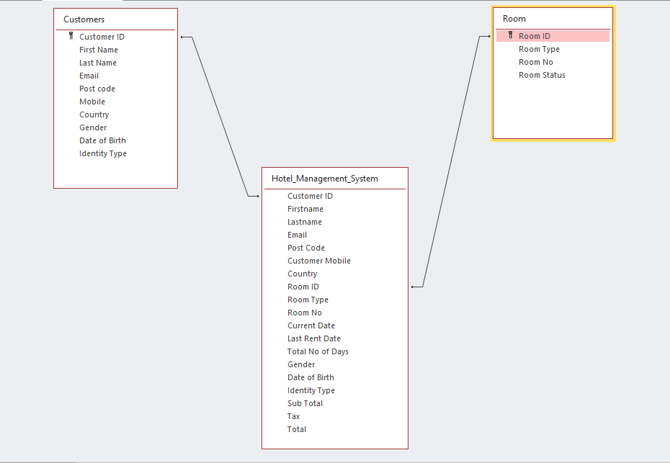

Coding:

Button Coding in Events:
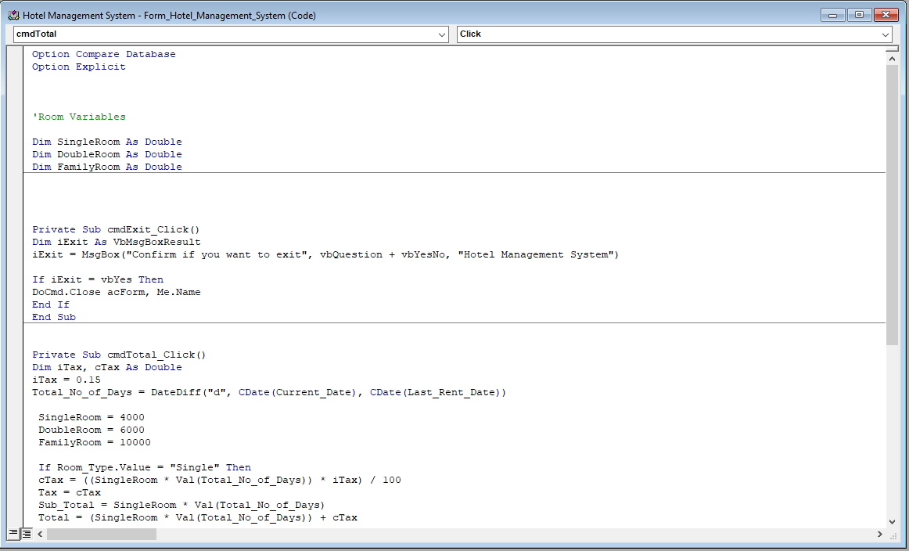

Syntax:

Option Compare Database
Option Explicit

'Room Variables

Dim SingleRoom As Double
Dim DoubleRoom As Double
Dim FamilyRoom As Double

Private Sub cmdExit_Click()
Dim iExit As VbMsgBoxResult
iExit = MsgBox("Confirm if you want to exit", vbQuestion + vbYesNo, "Hotel Management System")

If iExit = vbYes Then
DoCmd.Close acForm, Me.Name
End If
End Sub

Private Sub cmdTotal_Click()
Dim iTax, cTax As Double
iTax = 0.15
Total_No_of_Days = DateDiff("d", CDate(Current_Date), CDate(Last_Rent_Date))

SingleRoom = 4000
DoubleRoom = 6000
FamilyRoom = 10000

If Room_Type.Value = "Single" Then
cTax = ((SingleRoom * Val(Total_No_of_Days)) * iTax) / 100
Tax = cTax
Sub_Total = SingleRoom * Val(Total_No_of_Days)
Total = (SingleRoom * Val(Total_No_of_Days)) + cTax

ElseIf Room_Type.Value = "Double" Then
cTax = ((DoubleRoom * Val(Total_No_of_Days)) * iTax) / 100
Tax = cTax
Sub_Total = DoubleRoom * Val(Total_No_of_Days)
Total = (DoubleRoom * Val(Total_No_of_Days)) + cTax

ElseIf Room_Type.Value = "Family" Then
cTax = ((FamilyRoom * Val(Total_No_of_Days)) * iTax) / 100
Tax = cTax
Sub_Total = FamilyRoom * Val(Total_No_of_Days)
Total = (FamilyRoom * Val(Total_No_of_Days)) + cTax

End If

Tax = Format(Tax, "##0.00")
Sub_Total = Format(Sub_Total, "##0.00")
Total = Format(Total, "##0.00")
End Sub

Access Tables:
- Customers:
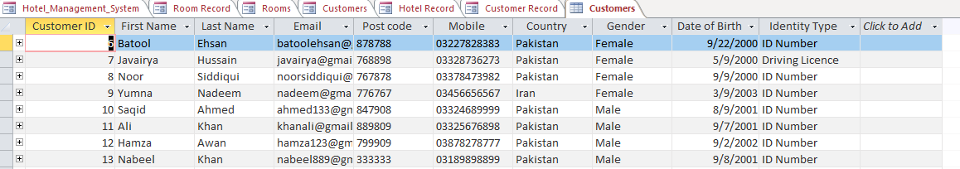
- Hotel System Data:
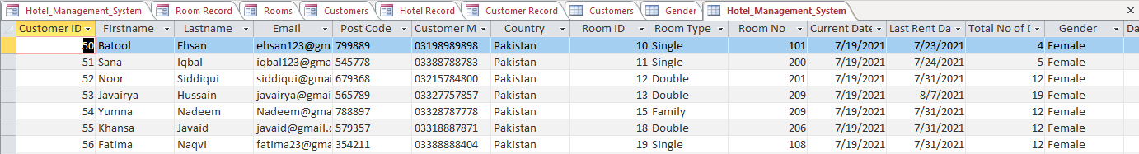
- Room Data:
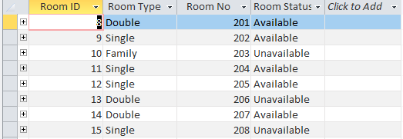

Reports of tables:
- Customer Report:
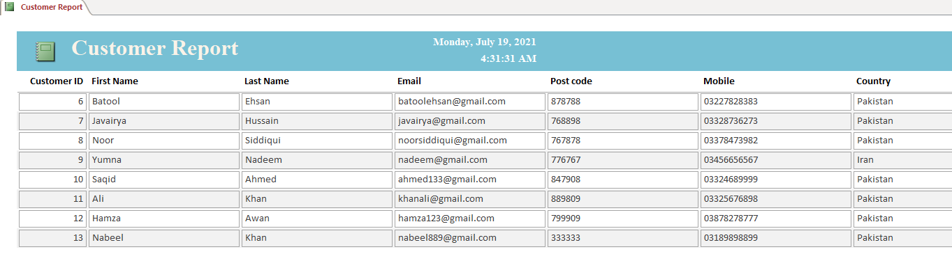
- Hotel Report:
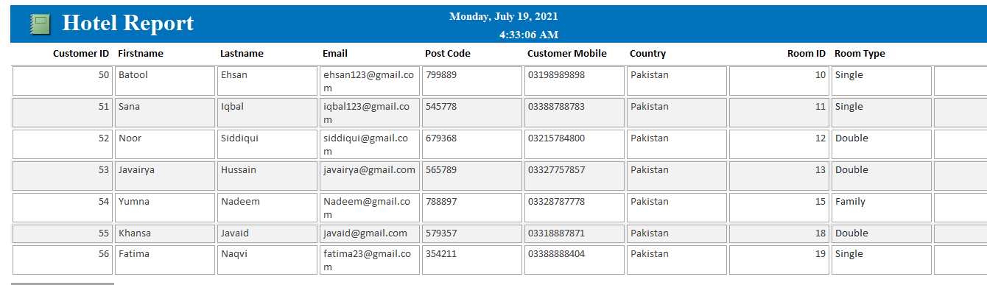
- Room Report:
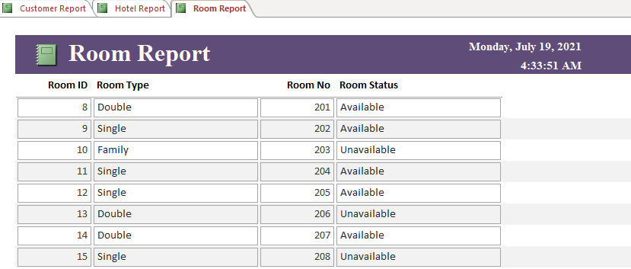

Schema Diagram:
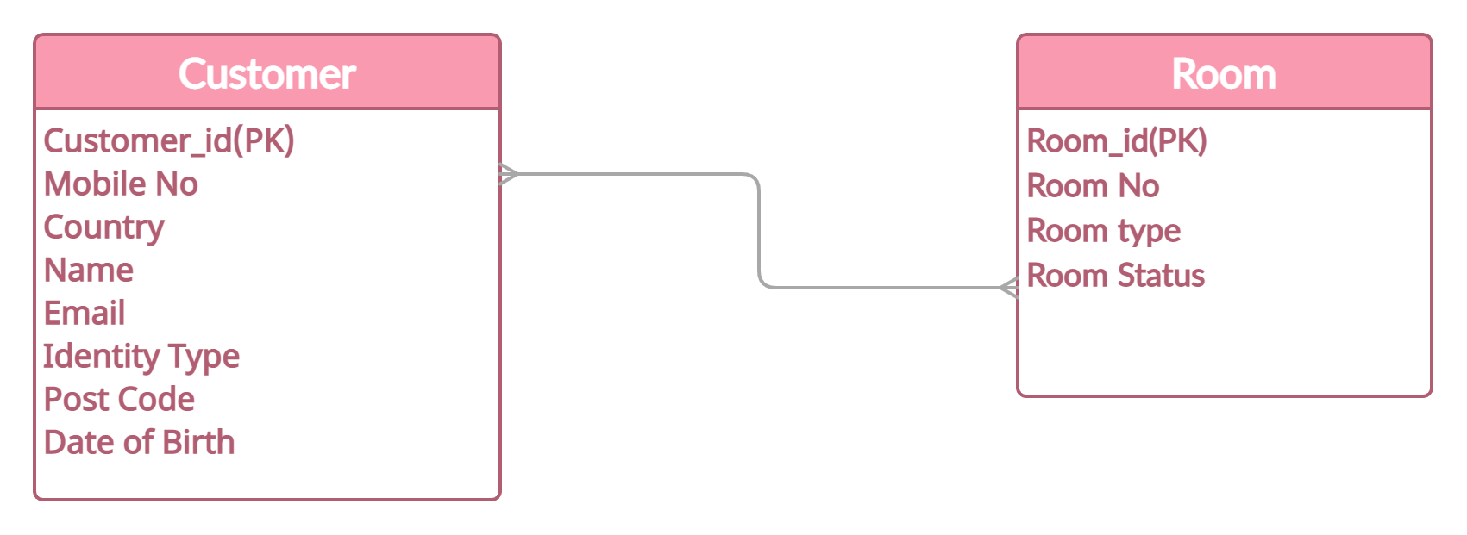

Entity Relation Diagram:
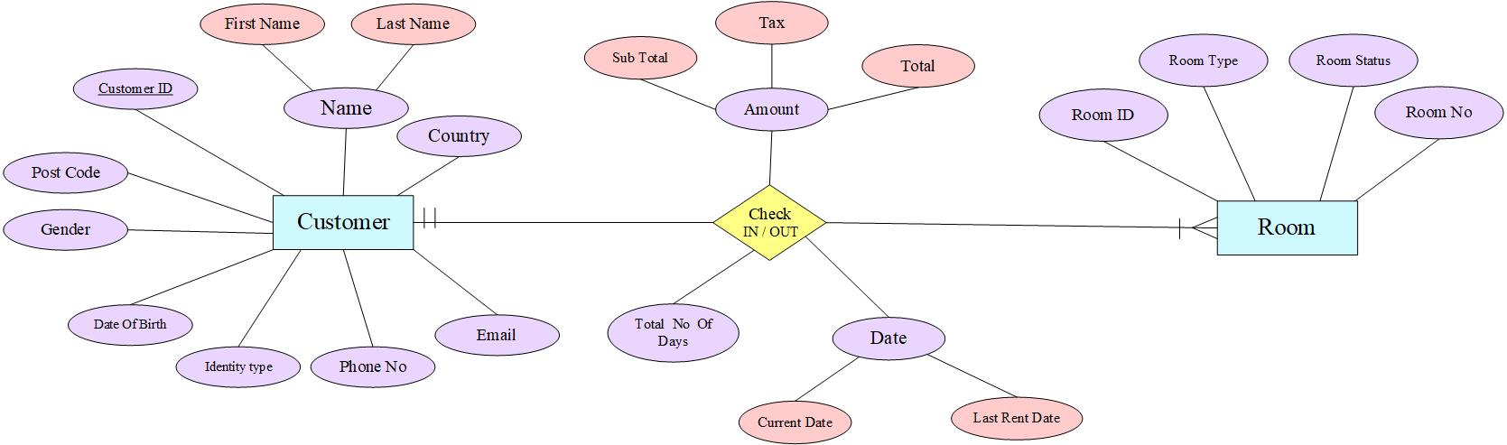

Screenshorts:
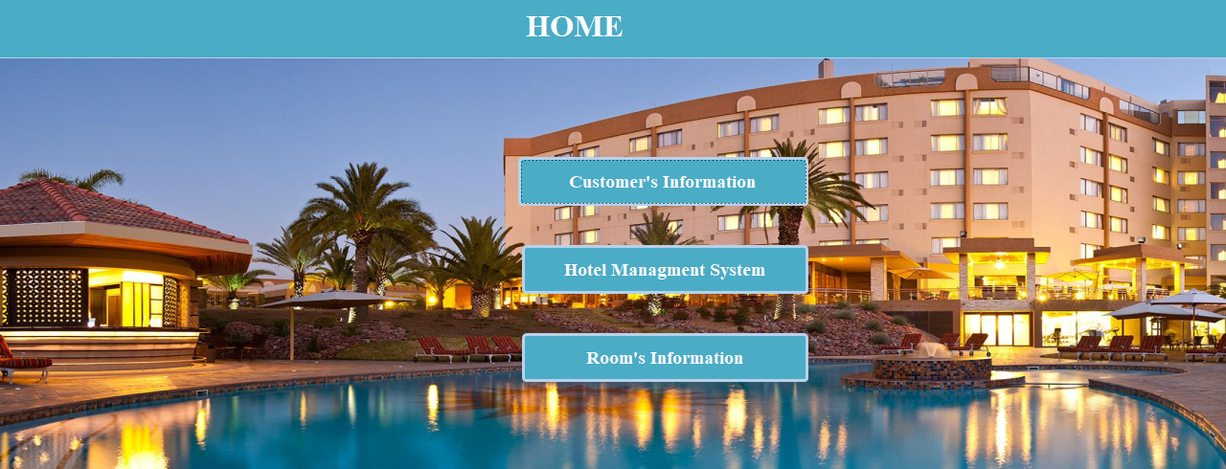
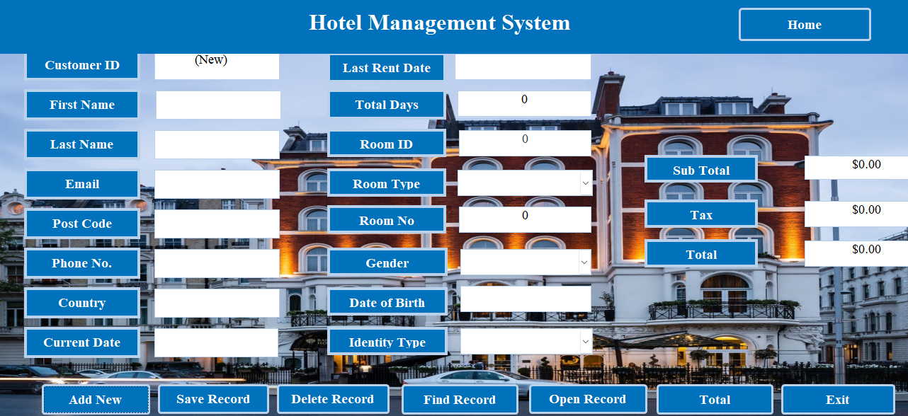
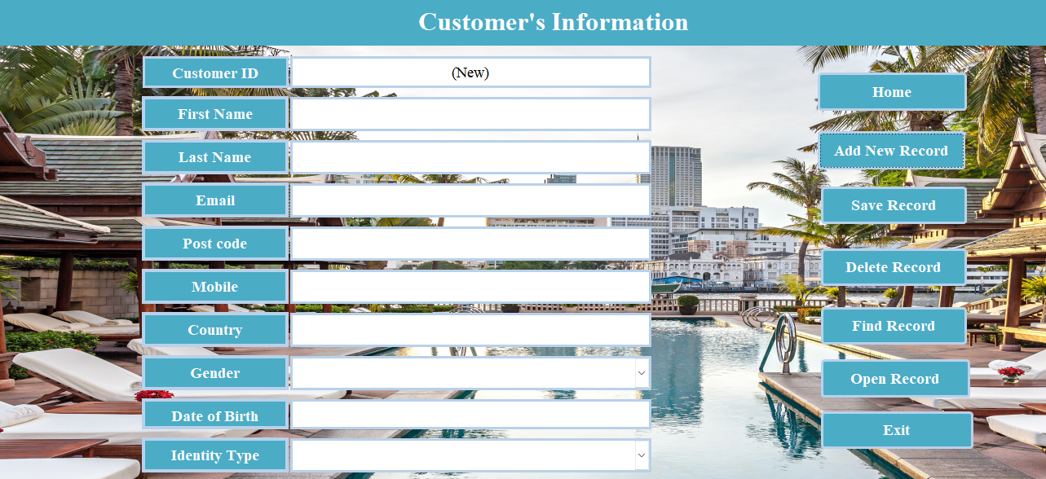
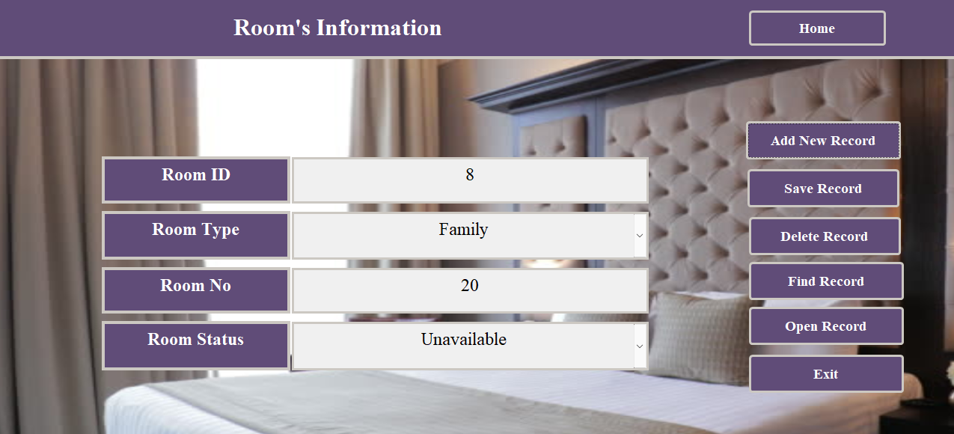

Conclusion:
The conclusion is that this project helps customers to add record, find record, delete record, open form, and we can also add customers data separately and we also add rooms on the requirements of the customers and we can also add whole data record of the hotel management system. Basically this system helps us to record everything about hotel system whether they are rooms type room status or anything.

